**Hydraulic Modeling of River and Stream Reaches Sampled in the Columbia Habitat and Monitoring Program (CHaMP)**

Matthew Nahorniak, Joe Wheaton, Carol Volk, Kelly Whitehead, Chris Jordan

**Introduction**

In support of efforts to quantify relationships between juvenile salmonid habitat and population dynamics, survey data from the Columbia Habitat Monitoring Program (CHaMP) have been used to develop hydraulic models for the majority of more than 600 reaches at which the CHaMP program collects habitat data. Hydraulic models are a key linkage being used in CHaMP to relate stream hydraulics to juvenile salmonid population dynamics.

The hydraulic modeling approach we’ve developed aims to provide hydraulic models capable of supporting CHaMP research, in terms of precision accuracy, as well as in the ability to generate unique hydraulic models for more than 600 CHaMP sites, at multiple flow conditions per site. To date, we have successfully modeled more than 900 CHaMP site / flow condition combinations.

Hydraulic model inputs include digital elevation models (DEM) developed from topographic surveys, estimates of surface roughness based on pebble size distributions, and discharge. Hydraulic model outputs include velocity vector and depth fields as well as information derived from these fields. All information used to generate model inputs are generated as part of default CHaMP data collection procedures.

Modeled velocities and depths are, in most cases, in excellent agreement with velocity and depth measured at a subset of sites for which validation data have been collected. There are exceptions, where certain topographic features such as undercut banks and porous structures, are not well represented in the DEM, resulting modeled values that fail to reflect measured values accurately. Impacts and strategies for improvement are discussed.

Overall, CHaMP hydraulic models are precise and accurate, and adequately support efforts to link stream hydraulics to habitat conditions.

**Background**

**CHaMP Program**

The Columbia Habitat and Monitoring Program (CHaMP) utilizes a spatially balanced, GRTS based statistical sampling design (Stevens and Olsen, 2004) to monitor more than 600 reaches, in qualifying wade-able streams and rivers accessible to anadromous O. Mykiss and/or chinook salmon, in the interior Columbia basin. A key objective of CHaMP monitoring is to quantify relationships between anadromous salmonid population dynamics and riparian habitat. Various empirical and mechanistic models are being investigated, including capacity models based on the net return on energy investment (NREI), which compares food availability from drift to the energy expenditure required to occupy a point in a flow field (Hayes et al, 2007); and habitat suitability index (HSI) models that consider depth and velocity in combination with other reach level information to estimate local carrying capacity. Velocity vector and depth field estimates at the reach level are required inputs for these models linking reach level CHaMP measurements to models of salmonid population dynamics that directly relate measured habitat to life stage specific abundance estimates (Figure 1).

Figure 1. CHaMP Data Flow from Reach Level Measurements to Life Cycle Modeling

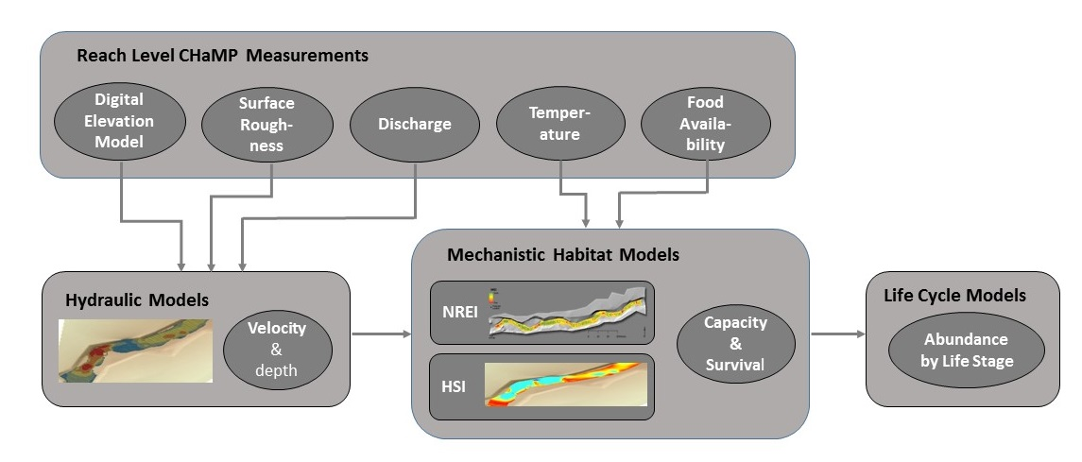

CHaMP generates digital elevation models (DEM) from high precision ground based topographic surveys (Ward et al, 2011). Such ground based surveys have become common sampling tools in fluvial geomorphology (Wheaton et al. 2010). Examination of measurement noise in CHaMP topographic surveys have demonstrated minimal crew-crew variability with respect to reach-reach variability (Bangen et al., 2014). CHaMP DEMs are produced for both reach level bathymetry (including non-wetted areas within the reach) and water surface elevation. Estimates of the thalweg (used to facilitate the generation of boundary conditions in hydraulic modeling) are also produced in conjunction with the DEM.

Various indicators of surface roughness are included in available CHaMP metrics, including parameters describing pebble size distribution. For our hydraulic models, we use the CHaMP metric D84, the 84th percentile of the pebble size distribution, as an indicator of surface roughness.

Discharge rates, in m3/s, are also measured for each CHaMP reach at the time of each survey. Reach level discharge is estimated as the average of discharge measured at multiple transects per reach, via integration of measured depth and velocity across selected transects.

**Methods**

**Modeling Strategy**

Our primary objective is to generate field estimates for depth and velocity, defined over the maximum practical spatial extent of each of our CHaMP surveys. Other hydraulic model outputs, such as vorticity and bed shear stress, are simply functions of the velocity and depth fields. Our additional challenge was to devise a modeling strategy that, in addition to providing accurate and spatially fine results, enables automation of the modeling process in order to produce thousands of hydraulic models. There are more than 600 unique CHaMP sites, and each CHaMP site will be surveyed from between three and nine times throughout the life of the CHaMP program; thus at minimum, we will have several thousand models to run. In addition to generating each hydraulic model, we also seek to generate easy to interpret quality control feedback, informative of the success and accuracy of each model.

We use Delft-3D Flow (http://oss.deltares.nl/web/delft3dto) to model fluid flow at our CHaMP reaches. Delft-3D flow is an open source, freely available software with modeling capabilities for free surface flows across a wide range of spatial scales (Deltares, 2013a). We chose Delft 3D not only because it is open source and freely available, but also because it is highly flexible and capable of modeling fluid flows that meet our current needs and potentially a broader suite of needs well beyond our current objectives. In addition to supporting the capabilities required for CHaMP hydraulic modeling, Delft 3D was selected as it is capable of being run in batch mode, suitable for our need to model large numbers of CHaMP reaches.

Inputs required for the hydraulic modeling are derived from CHaMP data, including digital elevation models (DEM) for both reach level bathymetry and water surface level elevation, an estimate of surface roughness, and water discharge rate. Required inputs describing modeled geometry, boundary conditions, initial conditions, fluidic properties, and numerical parameters are input to Delft 3D Flow as a series of input text files (Deltares, 2013a). Key input files include a “.grd” file describing the computational grid, a “.dep” file indicating the depth of the solid surface relative to the reference level, and “.bct” and “.bnd” files describing the location and condition of upstream and downstream boundary conditions. Additional files include a file outlining the grid, an optional file specifying dry points, and a master file including the filenames for all input files, as well as surface roughness and surface roughness model selection, fluidic properties, and numerical constants (simulation start time, time step, number of time steps, etc.).

Our modeling strategy reflects our objective to model high numbers of sites across a range of conditions, rather than intensively study a small number of sites. Where practical, we opted for simplicity, generally at the expense of computational efficiency. For example, we use simple rectilinear computational grids, rather than curvilinear or adaptive mesh grids. Our grid spacing is often finer than needed for much of the modeled flow, thus the computational intensity is perhaps greater than would be required if using a curvilinear grid. However, given the abundance of computational power available, in automating the process we found it vastly more effective to use simple rectilinear grids at the expense of computational efficiency, rather than add the complexity of attempting to automate and validate curvilinear grids for every site modeled.

For pre- and post-processing, we created scripts written in the R programming language (R Core Team, 2014). The pre-processing script reads a comma separated value (csv) files containing: the digital elevation model (DEM), which is generated from surveyed bathymetry; the water surface elevation digital elevation model (WSEDEM), also generated from the CHaMP survey; a csv file describing the surveyed thalweg location; and a file containing discharge, the 84th percentile value for site pebble size distribution (D84), and additional meta-data used for book-keeping and process tracking. The R script converts the input data into a series of input files formatted for the Delft-3D Flow software package (Table 1). The R script also generates a file of meta-data to be passed through the process and augmented during post-processing, and a suite of quality assurance plots form which the user can quickly confirm that boundary conditions and input files have been generated correctly.

**Table 1. Delft 3D Flow input files generated using a pre-processing R script (Deltares, 2013a)**

|  |  |
| --- | --- |
| **Delft 3D Flow Input File Created by Pre-Processing R Script** | **Description** |
| test.grd | File defining the numerical grid |
| test.dep | Bathymetry (depth) field inputs at all grid locations |
| test.enc | Grid enclosure file |
| test.dry | Dry points file |
| test.bct | Downstream boundary condition locations |
| test.bnd | Downstream boundary condition |
| test.src | Discharge locations |
| test.dis | Discharge rates |
| test.obs | List of observation points to track during solution (not currently used) |
| test.mdf | Master definition file; lists filenames for all other input files and contains key physical and numerical constants |

In addition to the standard set of Delft 3D input files, our pre-processing script generates a batch file script and accompanying xml file that enable running of the Delft 3D software in batch mode, bypassing any need for manual operation within the Delft 3D graphical user interface. This process is necessary to meet our high volume automation objective. Our pre-processing script also generates a macro that, after the Delft 3D Flow simulation is complete, runs the Delft 3D supplied Quickplot tool (Deltares 2013b) to convert Flow 3D results into a text format that can be read by a post-processing R script

A quality assurance plot showing the grid extents, wetted area, thalweg, upstream boundary condition extent and downstream boundary extent is also generated by the pre-processing script (Figure 2). This plot provides a quick visual confirmation that the input files have been read successfully and that boundary conditions are appropriate.

Figure 2. Extent of Reach Surveyed, Computational Grid Extents, and Inlet/Exit Boundary Locations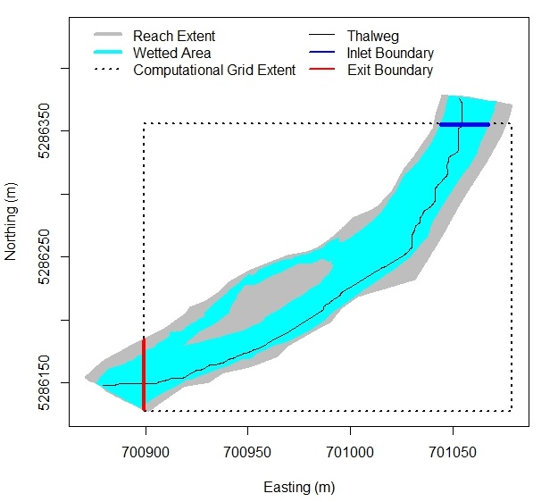

An additional R script conducts post-processing of the Delft 3D Flow results. Delft 3D Flow output, converted from Delft 3D Flow into a set of text files using the Quickplot tool, is read back into R, and results are interpolated back onto the spatial points defined on the original DEM grid. A csv output file of results is generated, as are a series of contour plots used for quality assurance. These QA plots visually display field results showing velocity, depth, water surface elevation, and bed shear stress. Plots of spatially explicit estimates of error in modeled depth are also calculated as the difference between surveyed depth and modeled depth. Plots of this error provide a quick visual assessment of model accuracy.

**Computational Grid**

Delft-3D supports the use of curvilinear orthogonal grids, enabling users to pack grid points more densely in areas of high depth and velocity gradients and/or areas of high interest. However, in support of the objective of automating hydraulic modeling of a large number of diverse sites, we chose instead to use a rectangular grid with uniform grid spacing in X and Y directions. We start by defining a rectangle with extents in the cardinal directions equal to the maximum and minimum extents of the DEM in each direction. Over this rectangle, we plot the thalweg, and determine to which edge (North, South, East, or West) the upstream and downstream ends of the thalweg are closest. The inlet and outlet boundaries are then trimmed by (in most cases) two meters, to ensure that the edges of the computational grid cross both wetted edges of the reach at both the inlet and outlet boundaries (Figure 2). While this results in some loss of total area modeled, it supports automation in that it provides a useful method to quickly define computational grid boundaries without the a-priori knowledge or manual user specification of upstream and downstream edges.

Note that, by limiting ourselves to a rectangular grid outlining the CHaMP reach, we necessarily include a significant area in our computational grid that is not part of the CHaMP reach. While this appears to be an inefficient use of computational power, we exploit the Delft-3D flow feature that allows for the definition of dry points. All computational grid points outside the CHaMP reach are defined as dry, and not considered in the computation of the hydraulic depth and velocity fields.

During development, we found we could consistently run models on computational grids containing approximately 500,000 grid points. Beyond that, memory requirements and computational requirements limited our ability to run successful models. Therefore, grid spacing used for the computational grid varies by the size of stream reach being modeled, such that we attempt to use as fine of a grid as computational practical without exceeding the 500,000 grid point limit. Additionally, we limit grid spacing options such that grid spacing is either a multiple of the 0.1 m DEM grid spacing, or an integer fraction of the DEM spacing, such that allowable computational grid spacing includes values such as .4, .2, .1, .05, or 0.025 meters, etc. (Figure 3). We found this simplified that process of translating and/or interpolating data to and from the DEM grid to the computational grid.

Figure 3. Comparison of DEM grid (fixed at 0.1 m grid spacing) and computation grid (grid spacing optimized, but at regular intervals of DEM grid).



To ensure our resulting grid spacing is sufficiently fine, we compared results of simulations run at grid spacing as described above, to those run at coarser grid spacing, across a variety of CHaMP reaches. Varying grid spacing demonstrated that the grid spacing, as determined from our algorithm, appears to be sufficiently fine. Doubling the grid spacing resulted in only minor deviations in velocity fields (figure 4) and corresponding depth fields. As grid spacing is further increased to 4X the default grid spacing, we observe significant differences in velocity and depth fields, indicating grid spacing should not be coarsened to this level.

Figure 4. Velocity magnitude differences, relative to simulations at default grid spacing, for simulations performed at 4X and 2X the default grid spacing, for low, medium, and high flow CHaMP reaches.



**Translating Bathymetry to Computational Grid**

The Delft 3D input file for bathymetry (test.dep) is generated by translating bathymetry elevation from the DEM grid onto the computational grid. Where points on the computational are co-located with points on the DEM grid, bathymetry elevation for the computational grid is simply assigned as the elevation of the corresponding point on the DEM grid. In instances where the computational grid spacing is less than the 0.1 m spacing of the DEM grid (point A on Figure 3), spatial interpolation is used to assign bathymetry elevation to the computational grid. The nn2 function from the R library RANN (Arya et al, 2014) is used to find the four nearest DEM grid points to the computational grid points. Because both grids are uniformly spaced in a rectangular grid, we are assured that the four nearest DEM points in a computational grid represent the four nearest DEM points form a square, within which the computational grid point is located.

**Boundary Conditions**

Boundary conditions are specified at the upstream and downstream computational boundaries (Figure 2). In doing so, we first determine which sides of the computational grid contain the upstream and downstream edges of the flow channel. To do this, we use the approximate thalweg X and Y locations as determined by the field crew, and approximate the water surface elevation at each thalweg location by interpolating from the WSEDEM onto the thalweg X Y points. Water surface elevation trend along the thalweg, over the length of the sites, indicates flow direction and can be used to differentiate upstream and downstream. Because we use the entire length of the stream, localized hydraulic jumps, WSE errors, etc., do not cause errors in determining upstream from downstream.

The upstream and downstream boundaries are determined by determining which boundary (North, South, East, or West) the thalweg crosses at the upstream and downstream ends, respectively. Note that the inlet and outlet can occur on the same edge of the computational grid.

Hydraulic discharge in m3/s is specified at the upstream computational boundary. This boundary condition is applied over the wetted length of the computational boundary crossing the upstream portion of the stream reach. Wetted length is defined as any portion of the inlet boundary with positive water depth, as determined by the difference in water surface elevation DEM and the DEM of bathymetry. The total discharge is distributed along each cell of the inlet boundary such that the volume flow rate at each cell is proportional to the measured water depth.

Water surface elevation is specified as the downstream boundary condition. Water surface elevation at the downstream boundary is estimated as the average water surface elevation at all wetted (according to the WSEDEM) points along the exit boundary. We specify the downstream boundary at all points along the exit face where the elevation is equal to or lower than the downstream water surface elevation, unless such points were already defined as inlet boundary locations. Because the inlet and outlet boundary conditions are specified at edges along cardinal directions, there is, in most cases, some boundary condition specification error due to the fact that the flow direction of the boundaries is rarely orthogonal to the boundary. In some cases, the wetted boundary edge, specified as a boundary condition along one edge only, may actually extend around a corner to an adjacent edge. Thus, as in most fluidic modeling, caution should be used in use and interpretation of modeled results near the computational grid boundary. However, experimentation with boundary conditions suggests that boundary condition errors typically propagate no more than 2-3 wetted widths upstream from the exit boundary or downstream from the inlet boundary.

**Initial Conditions**

Initial conditions for the model are set such that the water level at all points is set to the water level at the downstream boundary condition. Where the bed elevation is greater than the downstream boundary condition, no water is present at t=0. Initial velocity is zero for all wetted areas at t=0. While we recognize that computational time required to reach a steady state solution could potentially be improved by setting initial water levels closer to those as surveyed, we found that the steady state solution was not dependent on initial conditions.

**Surface Roughness and Model Calibration**

It’s impractical, both in terms of computational power and our ability to create DEMs at high enough precision, to include features in a DEM that can be described as “surface roughness” – pebbles, small rocks, etc. In CHaMP streams, surface roughness is primarily driven by the distribution of pebble sizes in the substrate, especially in the shallower, higher velocity channel units. Because features at this spatial level cannot be modeled directly, a model correcting for surface roughness is necessary. From the options available in the Delft 3D Flow software, we chose the White-Colebrook (Colebrook and White, 1937; Colebrook, 1939) model. Surface roughness in the X and Y directions are inputs to this model. We assume equal roughness in the X and Y directions, and that we can use information about pebble size distribution CHaMP as a proxy for surface roughness.

Pebble size distribution is measured at all CHaMP sites by randomly selecting pebbles at a series of transects across the wetted width of the stream. The 16th, 50th, and 84th percentile pebbles sizes are reported. We expect that hydraulic fields on the scale of interest are more affected by larger pebbles than smaller pebbles. Therefore, the CHaMP metric for the 84th percentile pebble size (D84) was considered as a potential indicator of surface roughness to use as inputs to the Delft 3D Flow model. We assumed some scalar value of D84 would provide a reasonable proxy for surface roughness, and thus used a scalar multiple of D84 as a means of model calibration. The scaling factor was varied over a range of values from 1 to 8, and resulting velocity and depth fields modeled at each scalar value were compared to a series of validation points, where velocity and depth were measured directly at a series of points along a series of transects, at a subset of CHaMP sites. We used 31 sites where validation data were collected, with from three to six transects collected per site, and up to 21 points per transect directly measured. The selection of our scalar on D84 to be used to input surface roughness was selected as the value that minimized the overall error when comparing modeled results to validation results.

Using a scalar multiplier on the CHaMP metric D84 proved effective at calibrating the model. As the multiplier was increased, modeled depth tended to decrease, while modeled velocity tended to increase (Figure 5). At a D84 multiplier of approximately 3.0, velocity and depth errors are minimized. We therefore use this multiplier for all CHaMP sites. Because our intention is to model thousands of CHaMP site / visit combinations, we use a single value for all sites, rather than attempt to optimize on a site by site basis.

Figure 5. Estimated mean error at validation locations vs multiplier applied to scale D84 as surface roughness input to model. Error is defined as the percent difference between modeled values for a) depth as measured in the DEM survey, b) direct depth measurements at validation points, and c) direct velocity measurements at validation points. Vertical bars indicate 95% confidence bounds.

**Simulation Time**

Typically in computational fluidic modeling, simulations would be run through simulated time until the user was satisfied, via some quantitative feedback, that the solution has reach a steady or quasi-steady state. Because our objective is to automate high numbers of simulations, we developed a conservative rule for total simulation time over which to run the simulations. From the DEM and water surface elevation DEM information, we estimate the volume of water present in the reach to be modeled. We run the simulation such that the rate of discharge multiplied by the simulation time is equal to twice the total water volume of the reach. Typically the simulation reaches a steady state when the total discharged volume is roughly equal to the total site volume, and we’ve found that doubling this simulation time seems to provide ample margin to ensure all simulations reach a steady state solution.

**Computation Time**

For CHaMP reaches modeled thus far, the clock time required to run each simulation can vary from a few minutes to as long as 24 hours, depending on the size of the reach and the discharge rates. Typically large reaches take longer to model, and sites with low discharge rates require longer times to model. Modeling all CHaMP sites in this manner is not practical at a single computer. Therefore, we take advantage of distributed cloud computing, running a single site on a single instance of the solution code set on each of multiple copies, accessed via the cloud.

**Outputs**

Table 2 lists the outputs we’ve selected as deliverables from our model. Outputs are recorded on a regularly spaced 10 cm grid, at all points that are either a) wetted, according to the hydraulic model solution, or b) wetted, according to the original crew survey. Outputs included for each grid point include: X and Y location (where X and Y are northing and easting, respectively), velocity vectors in X and Y directions, as well as resulting velocity magnitude, depth, and depth error (estimated as the difference between depth estimated in the survey, and depth estimated via the hydraulic model). In addition, a set of higher level attributes such as shear stress are output. These are calculated from the velocity and depth fields within the Delft 3D program.

**Table 2. CHaMP Site Hydraulic modeling output written to each row of the .csv output file. The output file contains one row for each point on a uniform 0.1 m rectilinear grid overlaying the CHaMP site**

|  |  |  |
| --- | --- | --- |
| **Output** | **Description** | **Units** |
| X, Y | Geographic Cartesian coordinates for Northing and Easting, respectively, in meters | m |
| X Velocity, Y Velocity | X and Y vector components of velocity | m/s |
| Velocity Magnitude | Magnitude of resultant velocity vector | m/s |
| Depth | Water depth | m |
| WSE | Elevation of water surface, above sea level | m |
| Bed Level | Elevation of bed, above sea level | M |
| Bed Shear X, Bed Shear Y | X and Y vector components of bed shear stress | N/m2 |
| Depth Error | Difference between surveyed depth and modeled depth | m |

**Quality Assurance Process**

Upon completion of hydraulic modeling, a set of quality assurance(QA) plots, generated automatically during the pre and post-processing, is examined to ensure validity of the results. Examination of these plots assures: validity of input data, validity of boundary conditions, and convergence of modeled results, as well as provide a check between modeled and measured results.

The input data is validated by examination of a raster plot of the input bathymetry, as translated to the numeric grid. If input data issues exist in the DEM data, or an algorithm error exists in the pre-processing code, this will show up visually as a discontinuity in this image.

Boundary condition validity is checked via examination of a QA plot showing the boundary conditions as generated in the pre-processing code (Figure 8). This is the most important of the QA plots, as most modeling errors found to date resulted from problems with boundary conditions. To date, approximately 95% of sites for which modeling has been attempted have valid boundary conditions. In roughly 5% of sites modeled boundary condition issues have been present (Figure 8). For the majority of sites with boundary condition errors, the problem can be resolved by adjusting either the trim length input, or by over-riding the automatically generated boundary specification produced by the pre-processing code. There are a small number of sites (~1% or less) for which we have been unable to model to date due to incapable boundary conditions.

Figure 8. Boundary condition error resulting from failure of automated process. Manual specification of the inlet boundary condition is required for this site.

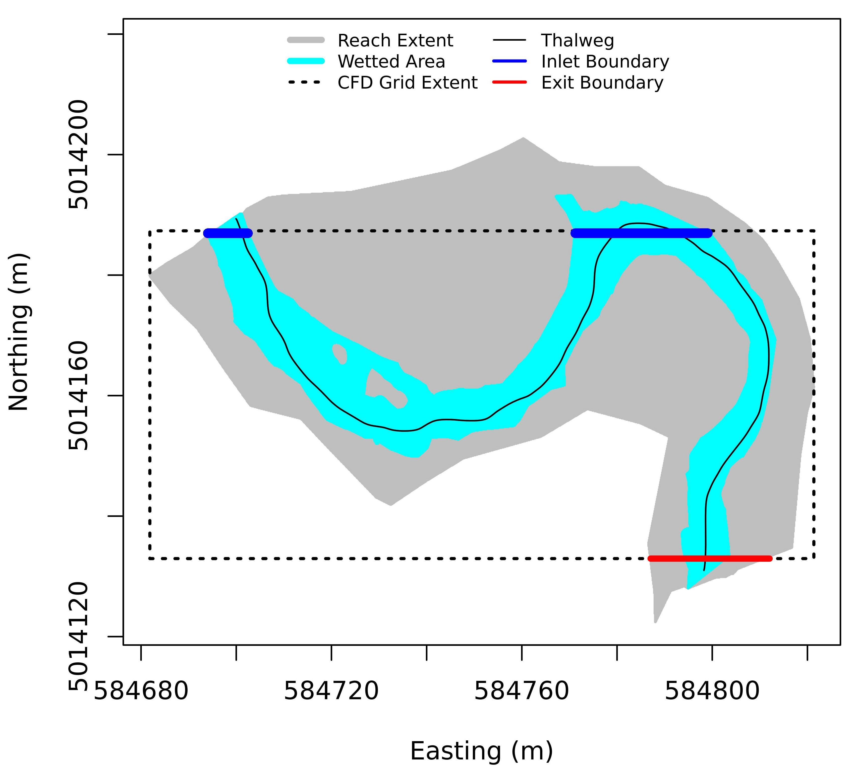

A raster plot of depth averaged velocity (Figure 6A) is examined to ensure convergence of results. If the simulation time is insufficient, there may be incomplete wetting of the channel apparent in the results, or there may be areas of zero velocity (where non-zero velocity is expected), or areas of unusually and unexpectedly high velocity. In such cases, the inputs can be modified to increase the simulation time to ensure the model has converged.

Finally, a QA plot that compared the measured water surface elevation to the modeled water surface elevation is generated (Figure 6D). If the overall modeled surface is significantly greater than or less than the measured surface, this may suggest, among other things, that the discharge or surface roughness is erroneous and should be checked. Local anomalies in this raster plot are likely the result of features in the stream that aren’t replicated in the DEM or other model inputs, such as bank undercuts, large woody debris, etc.

All modeled results are flagged as preliminary until they’ve passed the QA examination. Only after the QA process has been completed and a site has passed will results be uploaded to *champmonitoring.org*.

**Results**

We have been successful thus far at creating more than 1000 hydraulic models. For the CHaMP sites we have attempted to model thus far, we’ve successfully generated hydraulic model results for more than 97% of sites. Model failures and other problem areas will be discussed below. Publically available results for all sites modeled are available at *champmonitoring.org*.

Plots of velocity and depth, as measured at selected transect location for selected sites, compared to plots of modeled velocity and depth, as well as depth as surveyed and reflected in the DEM, show generally good agreement between modeled and measured values (Figure 6 and Figure 7). In general, modeled velocity and depth profiles are much smoother than direct measurements. Depth profiles as measured in the survey process, as reflected in the DEM, are also much smoother for modeled depth than directly measured depth. This is as expected, since the survey process operates at spatial scales larger than small localized features such as rocks, cracks, woody debris, etc. The precision of the modeled values are reflective of the DEM. Nevertheless, we find that, while the modeled values are smoothed out, they tend to match the overall depth and velocity profiles measured directly.

Figure 6. Velocity (A), depth (B), surface elevation (C), and the depth error estimated as the difference between surveyed depth and modeled depth (D), for CHaMP site ASW00001-SF-F5_P3BR.

Figure. 7. Example modeled depth and velocity compared to measured depth and velocity. DEM measured depth is depth derived from the DEM survey. Measured depth and velocity are direct measurements at transect locations. Transect locations are shown in inset map.



**Problem Areas**

Examination of spatial plots of the difference between modeled depth and surveyed depth, as reflected in the DEM and water surface elevation DEM differences, suggest that, for most sites, the modeled results accurately reflect measured values.

However, there are some riparian features have been problematic thus far: undercut banks, and large, sometimes porous woody structures. While undercut banks and porous woody structures are assessed as part of the CHaMP protocol, sufficient spatial detail is not recorded from which to include such features in the DEMs; thus impacts to the flow and velocity fields directly resulting from such features are not reflected in the hydraulic models.

For example, at CHaMP site ENT0001-1E3, the survey crew noted, and photographed, a large tree had fallen across most of the width of the river near the downstream extent of the reach. CHaMP Bathymetry measurements do not include fallen trees or other woody debris (although spatially non-explicit measures of woody debris are obtained by survey crews), but of course the impact of such woody debris is reflected in the surveyed water surface elevation. The hydraulic model, being driven by bathymetry, discharge rates, and boundary conditions, cannot account for the effect of the fallen log. Thus, we see large, localized depth field errors, and presumably analogous errors in the velocity field, immediately upstream of the location of the fallen log (Figure 9). In this case, the anomaly occurs near the downstream boundary condition, thus the error is propagated as an underestimate of depth upstream of the anomaly, rather than an overestimate of downstream depth below the anomaly, or a combination of the two.

Figure 9. Depth error, with respect to surveyed depth, for CHaMP site ENT0001-1E3. Localized area where modeled depth is underestimated, likely due to a fallen log in river. Logs, shrubs, and other woody debris is not reflected in the DEM, thus the increase in water surface elevation upstream from the log is not reflected in the hydraulic model.



Undercuts present another problem for the CHaMP hydraulic modeling. DEMs from CHaMP bathymetry surveys do not capture undercut area or depth; thus the DEM reflects a stream bank that runs vertically down from the edge of the overhanging bank, rather than an undercut bank. At CHaMP site ASW00001-NF-F4_P1BR, the crew observed and photographed a considerable undercut bank, and this undercut is not represented in the DEM. The modeled reach has, at undercut cross sections, a smaller than actual cross section width at wetted depths. The modeled flow is therefore more constrained than the actual flow, and the resulting modeled depth is greater the actual depth near the undercut locations (Figure 10). It should be expected that modeled velocity at these locations is greater than actual velocity as well.

Figure 10. Depth error, with respect to surveyed depth, for CHaMP site ASW00001-NF-F4_P1BR. The undercut bank, on the river left, is not reflected in the DEM thus. The hydraulic model over predicts depth because the modeled cross sectional area is less than the actual cross sectional area, by the amount of area in the undercut.



**Additional Modeling Capabilities**

**Modeling across ranges of discharge rates**

CHaMP hydraulic modeling has also been done, for selected site CHaMP visits, at flows above and below measured discharge rates, to model flow conditions different from those present when the DEM data were obtained. Problematically, the downstream water surface elevation is unknown, thus the downstream boundary condition cannot be specified accurately. While CHaMP is considering other data sources from which to estimates the downstream boundary condition, we can presently provide insight into the maximum range and extent of error propagation resulting from assumed, rather than measured, downstream boundary conditions. To examine this, we modeled a three CHaMP reaches – one each for relatively high flow, medium flow, and low flow rate streams, at both twice and half their measured discharge, using two downstream boundary conditions for each: One boundary condition specified no change in downstream water surface elevation, while the other specified a change in downstream water surface elevation such that the wetted cross sectional area is scaled in proportion to the change in discharge. In reality, it is reasonable to expect the correct downstream water surface elevation to be somewhere in between these two extremes, as the flow can be expected to get somewhat deeper and somewhat faster at increased discharge rates. The difference in velocity and/or depth fields between these two extremes provides a worst-case bound of the extent of error induced by an unknown, assumed downstream boundary condition, as well as a worst case limit for the extent of such error propagation. We found that, at worst case, the extent of errors introduced by varying discharge at an unknown downstream water surface elevation (Figure 11) were limited to a few wetted widths upstream, suggesting that, with caution and awareness, reaches can be modeled across a range of discharges.

Figure 11. Maximum velocity error and extent of error propagation at low, medium, and high flow rate CHaMP reaches, resulting from assumed exit boundary condition when modeling at discharge rates with unknown downstream water surface elevation. Maximum velocity errors are estimated as the velocity field differences (a-b) between modeled velocities at where downstream water surface elevations are assumed: a) unchanged from base flow, and b) downstream water surface elevation is adjusted such that exit boundary wetted areas are scaled proportional to discharge. Gray indicates no change in modeled velocities.



To date, we have successfully completed several batches of sites at multiple flow conditions. In the Methow, we modeled a set of 20 sites at 11 flow rates per site, in support of habitat modeling being performed by partners working in the Method. In addition, we completed a set of four sites in Catherine Creek (in the Upper Grande Ronde watershed) modeled at six flow rates per site, as well as a pair of Tucannon sites modeled at 3 flow rates per site, in support of habitat modeling and life cycle modeling in these watershed.

Future plans include ubiquitous modeling of CHaMP sites at multiple flow rates. While the flow rates have yet to be determined, we will likely model sites at summer low flows (as is currently the default), as well as two or three other flow typically present at critical life stages and/or seasons.

**Modeling of Porous Structures**

Default hydraulic modeling of CHaMP sites is based on a digital elevation model (DEM) of the site based on detailed topographic measurements. However, the DEM fails to capture any information about porous structures such as woody debris, beaver dams, etc. Since many restoration scenarios involve addition of porous structures to CHaMP sites, there is an effort underway to estimate the hydraulic changes resulting from the addition of such structures to CHaMP sites. These estimated changes in the hydraulic modeling results can then be carried forward into capacity estimation models (NREI, HSI).

Two basic steps are used to model porous structures. The first step is to manually modify the digital elevation model (DEM) in a manner consistent with the believed topographic response to additional of the porous structure to be modeled. Details of this are not discussed here as this step falls outside of the hydraulic modeling process. The next step is to add features to the model the simulate flow effects of porous structures.

In order to directly model the hydraulics of porous structures such as beaver dams and large woody debris in CHaMP sites, it would be necessary to obtain a highly detailed, 3D spatial model of the woody debris, which captured every wood surface for all wood pieces. The hydraulic model would then need to be run using a spatially fine 3D grid. Obviously, obtaining such detailed spatial information for woody debris is highly impractical; thus this is not viewed as a potential path forward. Instead, we intend to use the porous plate features available in Delft 3D flow to reproduce, approximately, the external effects on large woody debris, without attempting to model flow within woody structures themselves.

The porous plates features available in Delft 3D Flow allow specification of areas that act as porous plates, allowing flow to pass through but at increased levels of viscous friction, such that some additional kinetic energy dissipation results in higher water levels upstream of the porous plates and in some flow being diverted around the porous plate structures if possible. The spatial extent and the friction factor of the porous plates can be altered in ways which, if successful, will reflect, to a reasonably informative extent, the effects of actual large woody debris.

Locations of porous structures are manually defined and added to the hydraulic model via use of input “.ppl” input files (Figure 12).

Figure 12. Hydraulic modeling of porous structures. Location of porous plate grid cells is shown in black for Site OJD03458-000031, visit ID 667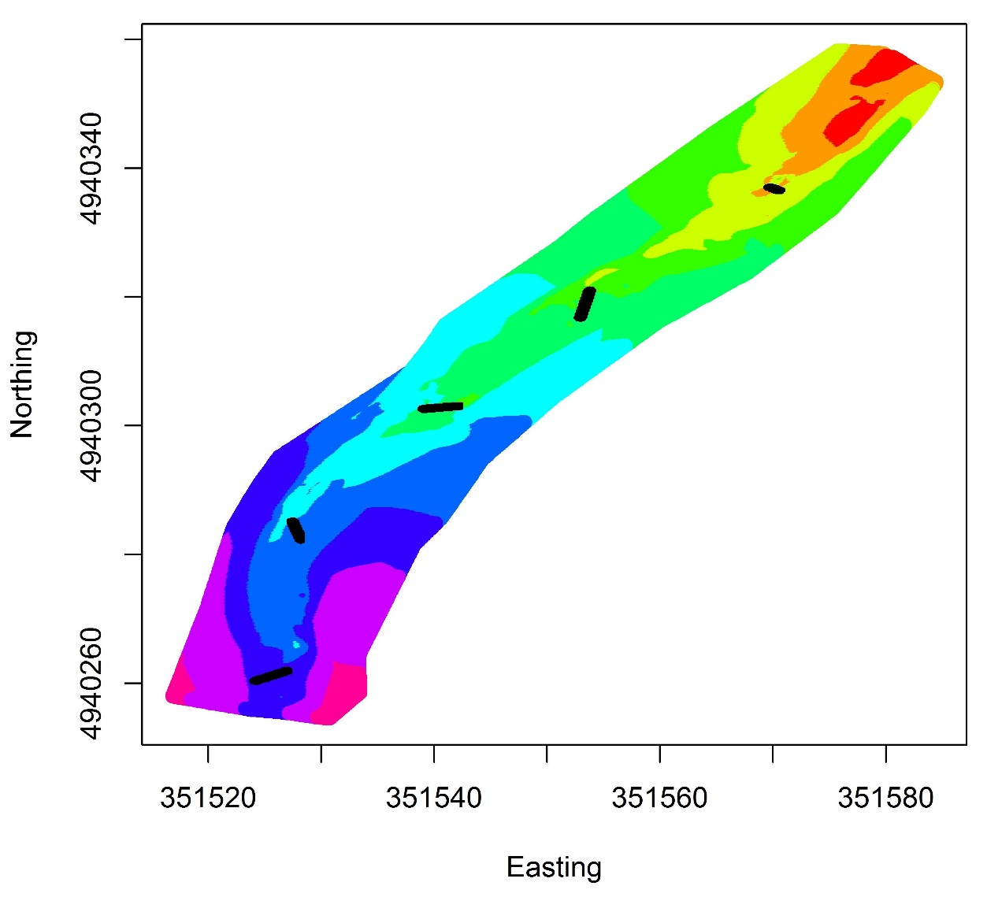

Adding porous structures can dramatically alter depth and velocity fields adjacent to the porous structures (Figure 13), which in turn may dramatically effect habitat quality as assessed by models such as NREI and HSI, which use hydraulic modeling results as inputs.

Figure 13. As measured, and modified with porous structure modeled depth and velocity for site OJD03458-000031 visit ID 667.

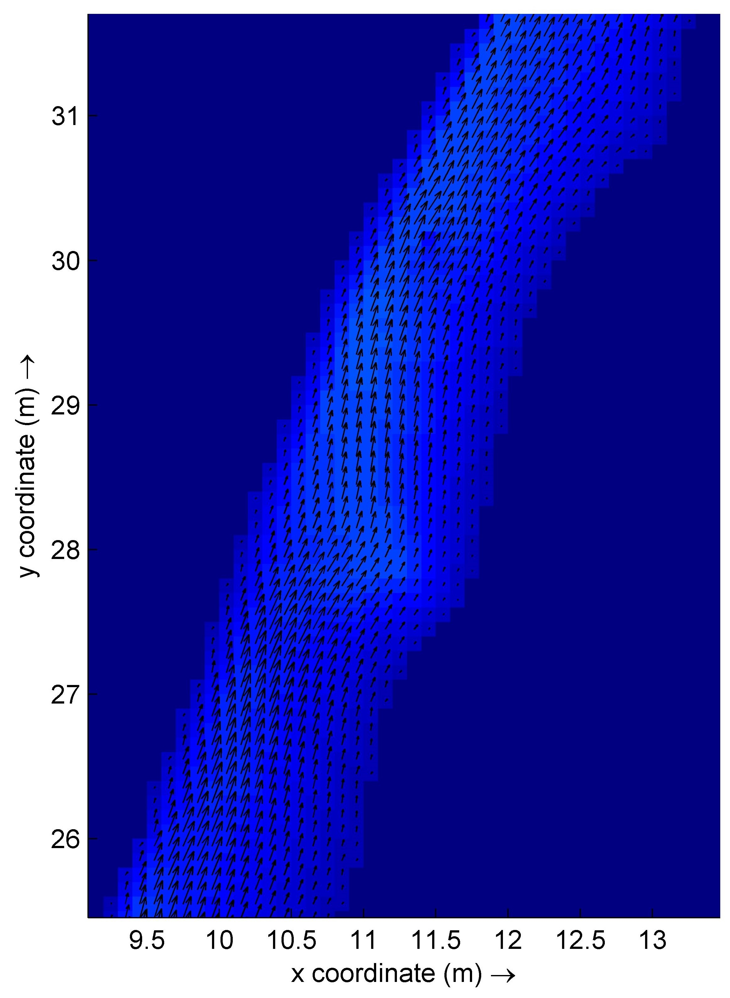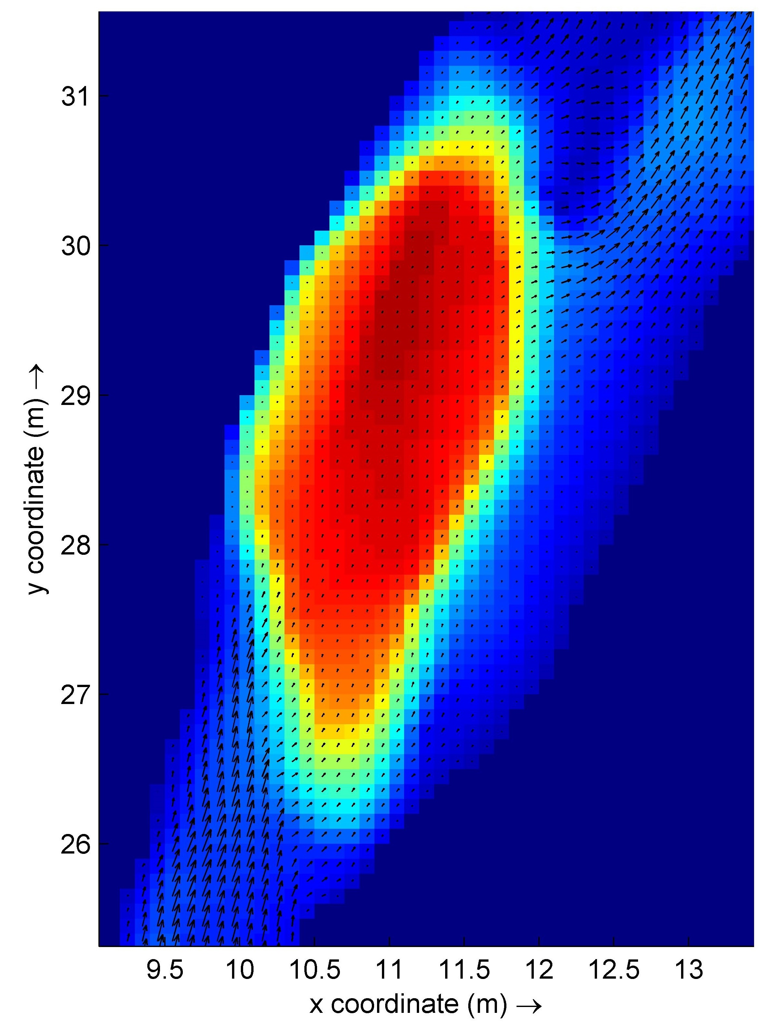

Depth (m)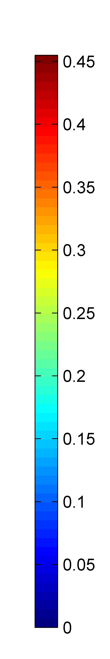

Porous Structure Location

**Using the Amazon web server to enable high volume modeling**

Running a hydraulic model on a single site may take anywhere from 10 minutes to 10 hours to run on a typical laptop. Required computation time is dependent primarily on processor speed, size of the CHaMP site, and flow rate. Because of the computation time required, it is not feasible to run all sites, at all desired flow rates, on a single computer.

To enable modeling of 1000’s of CHaMP site visits, at multiple flow rates, we utilize the Amazon Web Service (AWS). We have created a virtual machines on which the Delft 3D Flow program, as well as our R-code, are present. Input data files are stored on an AWS “bucket”, which can be access via the virtual machine. Virtual machines on the AWS server can then be cloned, and multiple copies can be run simultaneously, providing virtually unlimited computing capacity at a reasonable cost.

Typically, up to 25-30 sites can be modeled in a given batch on a single instance of a virtual machine. The batch size is limited by the memory allocated for each virtual machine, and there are tradeoffs to be made between available memory and cost. Through experimentation, and considering available memory, processor speed, and cost, we selected the AWS instance type of “C4.4xLarge” as the virtual machine type for CHaMP hydraulic modeling.

**Discussion**

We have to-date generated hydraulic models for more than 600 CHaMP reaches, estimating depth and velocity fields for the discharge rates at the time of measurement. We believe these results are accurate and precise enough to be utilized in the development of salmonid habitat models such as NREI and HSI, and this work is currently in process. Hydraulic model results are publically available via *champmonitoring.org*, and we encourage their use in additional applications as researchers see fit.

One of the over-arching goals of the CHaMP program is to quantify the effect habitat restoration will have on salmonid population dynamics. Hydraulic modeling can play a key role in quantifying such links. Restoration scenarios can be described digitally by altering measured DEMs, modifying discharge rates to simulate restored flows, or changing surface roughness to model changes in surface features, for example. Creating these hydraulic models as inputs to habitat models such as NREI or HSI can provide low cost, zero impact assessments of restoration actions prior to any actual physical restoration. This enables not only a quantitative comparison of multiple restoration options, but a methodology for optimizing restoration given a restoration strategy.

Results to date are primarily limited to discharges as measured at the time surveys were performed. Often this is at or near summer low flows - likely a critical time in the juvenile salmonid life cycle. However, given that for most reaches it is likely possible to estimate discharge ranges throughout the year, it is reasonable to expect that CHaMP produce models for discharge rates outside of the measured ranges. Thus, in conjunction with follow on models, we could produce date specific estimates of NREI, HSI, etc.

Porous structures, including large woody debris, beaver dams, undercuts, and similar features are important to salmonids and other fish species, but are not well represented by CHaMP DEMs. We are developing strategies, taking advantage of additional features of the Delft 3D software, for simulating such structures. For example, a porous structure such as a beaver dam may be approximated by modeling it as a series of porous plates. As a program, we will examine tradeoffs between additional efforts in surveying and mapping important features such as undercuts and woody debris, with insight to be gained from this additional detail at the modeling stage.

Arya S., Mount D., Kemp S.E., Jeffries G. (2014): Fast Nearest Neighbour Search (wraps Arya and Mount's ANN library). Version 2.4.1.

Bangen S, Wheaton JM, Bouwes N, Jordan C, Volk C, Ward MB, 2014. Crew variability in topographic surveys for monitoring wadeable streams: a case study from the Columbia River Basin. Earth Surface Processes and Landforms, 2014.

Colebrook, C.F. (February 1939). "Turbulent flow in pipes, with particular reference to the transition region between smooth and rough pipe laws". *Journal of the Institution of Civil Engineers* (London).

Colebrook, C. F. and White, C. M. (1937). "Experiments with Fluid Friction in Roughened Pipes". *Proceedings of the Royal Society of London. Series A, Mathematical and Physical Sciences* 161 (906): 367–381.

Deltares (2013a). Delft3D-FLOW: Simulation of multi-dimensional hydrodynamic flows and transport phenomena, including sediments. User Manual. Version: 3.15.26466.

Deltares (2013b) Delft3D-QUICKPLOT: Visualisation and animation program for analysis of simulation results. User Manual. Version: 2.15.23866.

Hayes, J.W., Hugues, N.F., Kelly, L.H. Process-based modelling of invertebrate drift transport, net energy intake and reach carrying capacity for drift-feeding salmonids, Ecological Modelling 207, 2007.

R Core Team (2014). R: A language and environment for statistical computing. R Foundation for Statistical Computing, Vienna, Austria. URL <http://www.R-project.org/>.

Stevens Jr DL, and Olsen AR (2004). Spatially balanced sampling of natural resources. J Am Stat Assoc, 99:465, 262-278, DOI: 0.1198/016214504000000250.

Ward MB, Nelle P, Walker SM. (editors) (2011). CHaMP: 2011 pilot year lessons learned project synthesis report. Prepared for the Bonneville Power Administration by CHaMP. Published by Bonneville Power Administration, Portland, OR. 95 pages.

Wheaton JM, Brasington J, Darby SE, Merz J, Pasternack GB, Sear D,

Vericat D. 2010. Linking geomorphic changes to salmonid habitat at a scale relevant to fish. River Research and Applications 26: 469–486.